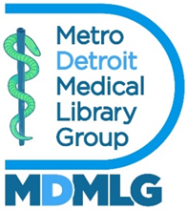

Metropolitan Detroit Medical Library Group

Outreach Committee Annual Report

June 2, 2025

**Margaret Danowski MDMLG Student Award**

The Margaret Danowski MDMLG Student Award received 7 applicants in the Fall of 2024. Wayne State University School of Information graduate student Sarah Patino was chosen by MDMLG Executive Board members to receive the Margaret Danowski MDMLG Student Award of $350.

**MDMLG Student Representative**

MDMLG student member Jillian Beckwell served as MDMLG Student Representative, starting in September with a one-year term. A search will initiate shortly to reach out to students at Wayne State and the University of Michigan to replace her as she transitions into Outreach Chair for the 2025-2026 year.

**Presentations, Publications, and AHIP Status List**

Presentations, publications, and AHIP statuses will be compiled into a bibliography and made available in the Summer 2025 Newsletter as well as on the MDMLG website.

**MDMLG Outreach Tasks**

* Regular MDMLG outreach tasks were completed throughout the year, including:
* Updated Job Bank with new postings; removed old/expired postings
* Sent welcome emails to all new members
* Monitored mentor/mentee sign-up (no activity in this area)

Submitted by,

David Stewart, Outreach Officer